Note: Use at least 200% zoom for better view of the following Screen-shots

SHORT calibration Screen-shot
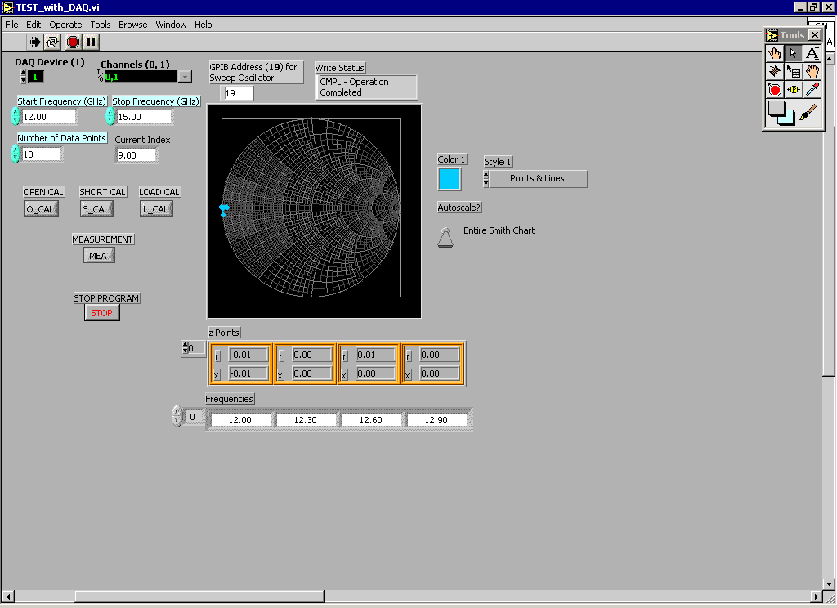

OPEN calibration Screen-shot
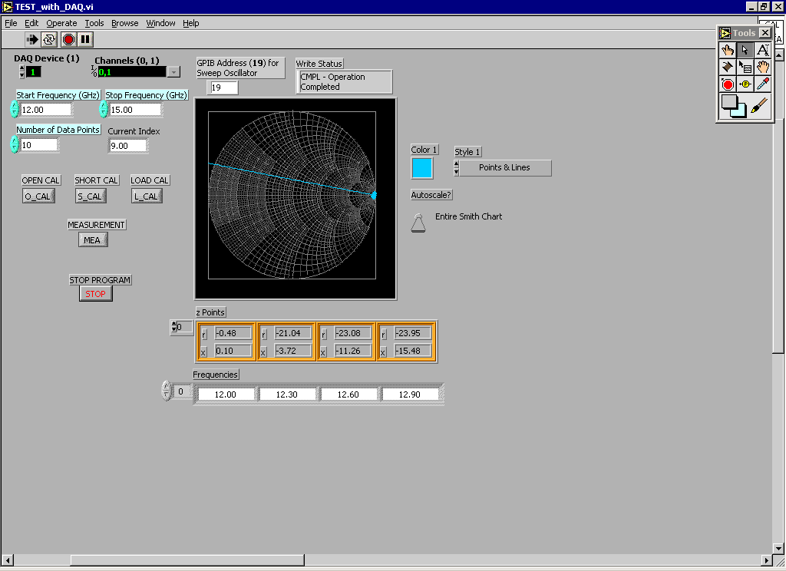

LOAD calibration Screen-shot
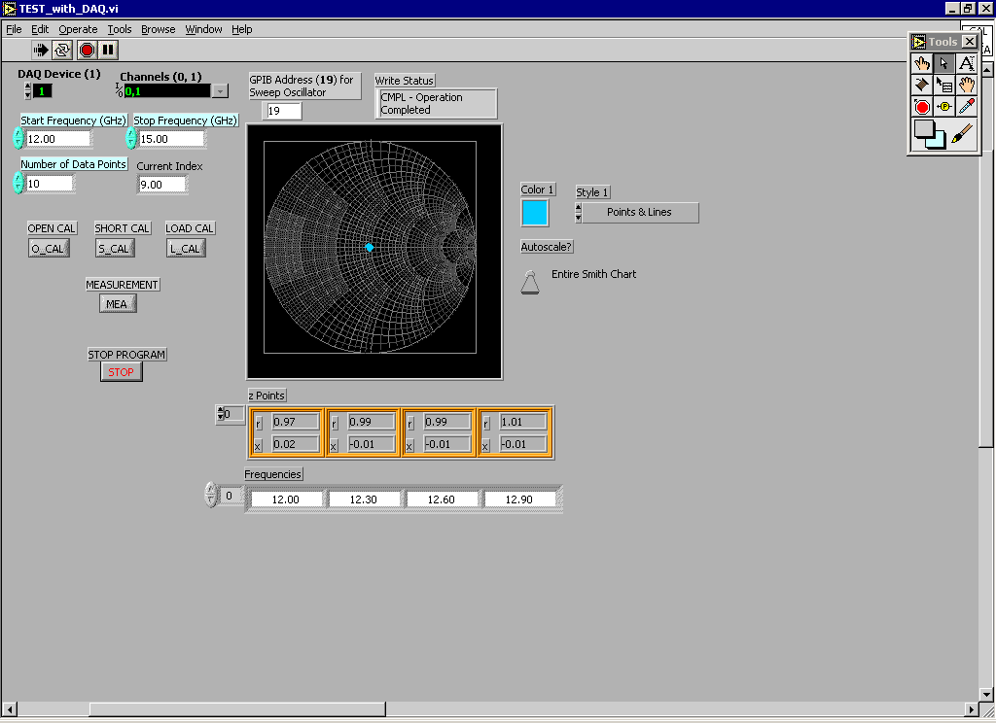

Screen-shot for a Measurement when Plane Extension was adjusted
